**ER Diagram**

**Relationships**

**Reference: The website I used to create my ER Diagram is eraser.io**

**Here I created the entities and attributes emphasising what the primary keys are.**

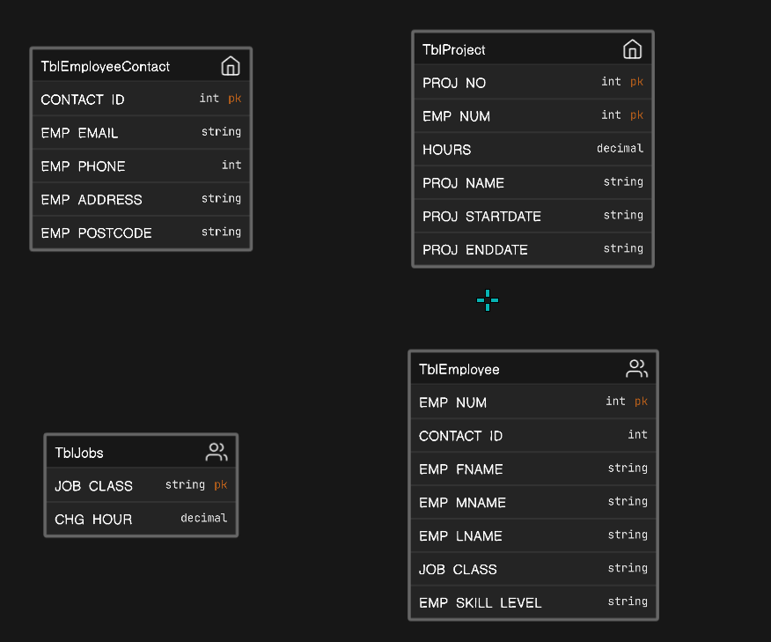

Next I started using crows foot to create connections. I will first target the primary and foreign keys.

Firstly, I started with ContactID attribute in the entity TblEmployeeContact. I connected ContactID from TblEmployeeContact to TblEmployee’s foreign key attribute which is also named ContactID. However, the key is foreign. The Crows foot notation I decided to use is one to one to one as each employee/staff has their own unique contact. Diagram for the connection:

I then linked JOB_CLASS to EMP_NUM. This is important as

I then connected PROJ_NO in the PROJECT table to EMP_NUMBER in the EMPLOYEE table with a one to many line on the EMP_NUMBER end. This is important as it indicates that a project can have multiple employee records, but each employee is associated with only one project.

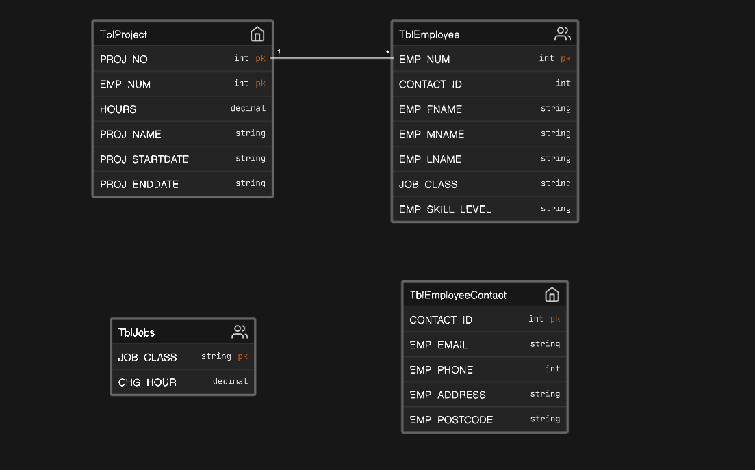

I then connect EMP_NUM in the EMPLOYEE table to CONTACT_ID in the CONTACT table with one to one line. This is important as it indicates that each employee is associated with a single record one contact, and each contact is associated with one employee.

